Website Documentation
Website Name: SaucetoGo

My First week of creating my website is all about decision and making the foundation of my website, but first of all why my website is SaucetoGo because its my business idea and I want to try and create the website.
SAUCETOGO is a clean, modern landing page created for a brand of specialized sauces. Orange, black, and white make up the website's vivid, energetic color scheme, which matches the products' fierce and daring qualities. To encourage user interaction and online orders, the design emphasizes simple layout, amusing unique drawings, and clean style .
I make first the Navigation & Header section The header is consistent across all views, featuring a bold orange background with the brand logo pinned to the left and navigation controls to the right.
After that I make the home section The entrance of the website relies on strong visual hierarchy and a punchy, localized tagline to grab attention immediately.
And about us section This section shifts to a clean white background to emphasize readability, giving the brand a grounded, premium identity.
The menu section A distinct dark-mode section (charcoal grey background) designed to make the vibrant colors of the product packaging pop off the screen.
The contact us section A minimalistic, highly functional footer area layout containing the primary inquiry points.
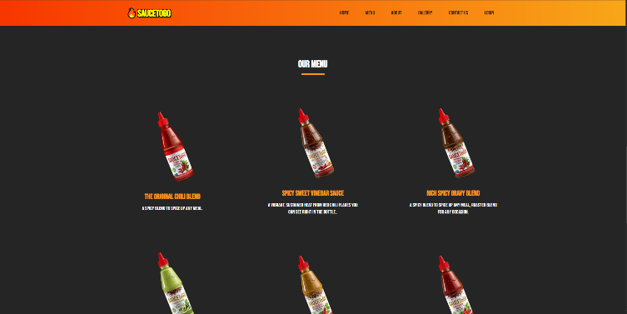
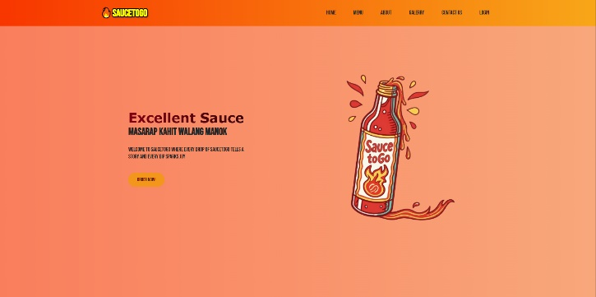
And the last is the footer The page finishes with a thin, dark ash footer row containing basic legal compliance links:
